Project Design Phase-II
Data Flow Diagram & User Stories

Date | 27 June 2025
Team ID | LTVIP2025TMID34134
Project Name | Pollen's Profiling: Automated Classification of Pollen Grains
Maximum Marks | 4 Marks

Data Flow Diagrams:
The Data Flow Diagram (DFD) visually represents how data flows within the "Pollen’s Profiling" system. This system is designed to automate the classification of pollen grain images using a Convolutional Neural Network (CNN) model deployed via a Flask web application. The DFD helps in understanding the overall architecture, including inputs, processes, and outputs.
Example: DFD Level 0 (Industry Standard)
Example:
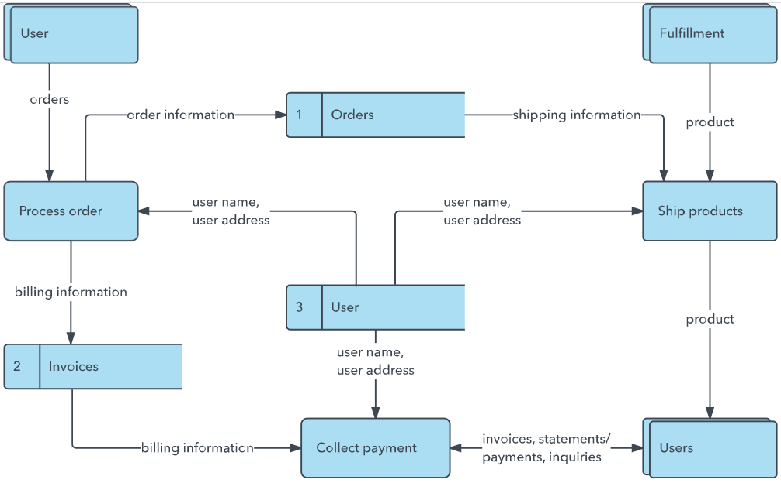


User Stories
Use the below template to list all the user stories for the product.
User Type | Functional Requirement (Epic) | User Story Number | User Story / Task | Acceptance criteria | Priority | Release
Customer (Mobile user) | Registration | USN-1 | As a user, I can register for the application by entering my email, password, and confirming my password. | I can access my account / dashboard | High | Sprint-1
 | Registration | USN-2 | As a user, I will receive confirmation email once I have registered for the application | I can receive confirmation email & click confirm | High | Sprint-1
 | Registration | USN-3 | As a user, I can register for the application through Facebook | I can register & access the dashboard with Facebook Login | Low | Sprint-2
 | Registration | USN-4 | As a user, I can register for the application through Gmail | I can log in via Gmail and access dashboard | Medium | Sprint-1
 | Login | USN-5 | As a user, I can log into the application by entering email & password | I can log in using valid credentials | High | Sprint-1
 | Dashboard | USN-6 | As a user, I can view my profile and recent activity | Profile and activities are shown on the dashboard | High | Sprint-2
Customer (Web user) | Registration | USN-7 | As a web user, I can register using email and password | Account is created and accessible | High | Sprint-1
 | Login | USN-8 | As a web user, I can log in via email/password | Successful login gives access to dashboard | High | Sprint-1
 | Dashboard | USN-9 | As a web user, I can see uploaded pollen images and predictions | Images and prediction results are visible | High | Sprint-2
 | Dashboard | USN-10 | As a web user, I can upload images for pollen prediction | Uploaded images are processed and results shown | High | Sprint-3
Customer Care  Executive | User Support | USN-11 | As an executive, I can view user complaints/feedback | I can access and filter support tickets | High | Sprint-3
 | User Support | USN-12 | As an executive, I can respond to user queries | User receives timely and clear responses | High | Sprint-3
 | Report Handling | USN-13 | As an executive, I can generate user support reports | Weekly/monthly reports can be generated and exported | Medium | Sprint-4
Administrator | User Management | USN-14 | As an admin, I can view statistics like number of users, usage trends | Real-time stats visible in admin dashboard | High | Sprint-2
 | Analytics | USN-15 | As an admin, I can upload and update pollen dataset | Updated datasets reflect in model prediction | High | Sprint-3
 | Dataset Management | USN-16 | As an admin, I can modify site/app settings | Changes in settings are reflected across user apps | Medium | Sprint-4
 | App Configuration | USN-17 | As an admin, I can view and manage all registered users | Admin can block, delete, or edit user details | Medium | Sprint-4

